Infosys Springboard Virtual
Internship

“Edu2Job”: Predicting Job Roles
from Educational Background

Milestone 1 - User Authentication &
Profile Management

Name: Adiya T V

Date: 24-11-2025

Milestone 1 - User Authentication & Profile Management
1.Introduction

The Edu2Job project aims to assist students and professionals in discovering suitable job roles based on their educational background and skills using Machine Learning and Data Analytics.
Milestone 1 focuses on building the foundational layer of this application: User Authentication and Profile Management. Before the system can predict job roles, it requires a secure environment where users can register, log in, and manage their academic data. This phase implements secure access using JWT (JSON Web Tokens) and Google OAuth, ensuring that user data is protected and retrievable via a personalized dashboard.

2.Objective

The primary objectives for Milestone 1 were to:
- Implement Secure Authentication: Develop a backend system to handle user registration and login using encrypted passwords (bcrypt) and JWT for session management.
- Integrate Google OAuth: Enable one-click sign-in using Google accounts for a seamless user experience.
- Develop User Dashboard: Create a frontend interface where users can view their profile and prediction history.
- Profile Management: Allow users to update their personal and educational details, which will serve as the input for the ML model in future milestones.
- Database Integration: Set up a MongoDB database to store user credentials and profile data securely.

3.Workflow

The system follows a standard Client-Server architecture:
- User Action: The user attempts to Sign Up, Log In, or use "Sign in with Google" on the frontend.
- API Request: The frontend sends a POST request to the backend (Node.js/Express).
  - Standard Auth: Sends Email/Password.
  - Google Auth: Sends the Google ID Token retrieved from the Google Identity Services.
- Backend Processing:
  - The server validates inputs or verifies the Google Token.

  - Passwords are hashed using bcrypt before storage.
  - If successful, the server generates a JWT (Token).
- Token Storage: The frontend receives the JWT and stores it in localStorage.
- Access Protected Routes: For subsequent requests (like fetching the Profile Dashboard), the frontend sends the JWT in the Authorization header. The backend verifies this token before returning sensitive user data.

4.Code Implementation

Index.js:

require('dotenv').config();
const express = require('express');
const path = require('path');
const cors = require('cors');
const jwt = require('jsonwebtoken');
const bcrypt = require('bcrypt');
const { OAuth2Client } = require('google-auth-library');

const connectDB = require('./config/db');
const User = require('./models/User');
const app = express();
const PORT = process.env.PORT || 3000;

const JWT_SECRET = process.env.JWT_SECRET || 'dev_jwt_secret';
const JWT_EXPIRES = process.env.JWT_EXPIRES || '7d';
const BCRYPT_SALT_ROUNDS = parseInt(process.env.BCRYPT_SALT_ROUNDS || '10', 10);

const GOOGLE_CLIENT_ID = '526435487486-oeipknm1gvcf17be6qb9gn8c0r9i42an.apps.googleusercontent.com';
const googleClient = new OAuth2Client(GOOGLE_CLIENT_ID);

const MONGO_URI = process.env.MONGO_URI || 'mongodb://127.0.0.1:27017/job_role_predictor';
connectDB(MONGO_URI);

app.use(cors());
app.use(express.json());
const FRONTEND_PATH = path.join(__dirname, '..', 'frontend');
app.use(express.static(FRONTEND_PATH));

function generateToken(user) {
return jwt.sign(
{ id: user._id.toString(), username: user.username, email: user.email },
JWT_SECRET,
{ expiresIn: JWT_EXPIRES }
);
}

function authenticateToken(req, res, next) {
const authHeader = req.headers['authorization'];
const token = authHeader && authHeader.split(' ')[1];
if (!token) return res.status(401).json({ message: 'Token required' });

jwt.verify(token, JWT_SECRET, (err, payload) => {
if (err) return res.status(403).json({ message: 'Invalid or expired token' });
req.user = payload;
next();
});
}

app.get('/', (req, res) => {
res.send('Job Role Predictor Backend (MongoDB + JWT + Google OAuth)');
});

/**
* POST /register
* Body: { username, email, password }
*/
app.post('/auth/register', async (req, res) => {
try {
const { username, email, password } = req.body;
if (!username || !email || !password) return res.status(400).json({ message: 'username, email and password required' });

const existing = await User.findOne({ email: email.toLowerCase() });
if (existing) return res.status(409).json({ message: 'Email already in use' });

const passwordHash = await bcrypt.hash(password, BCRYPT_SALT_ROUNDS);
const user = new User({ username, email: email.toLowerCase(), passwordHash });
await user.save();

const token = generateToken(user);
res.status(201).json({ message: 'Registration successful', token, user: { id: user._id, username: user.username, email: user.email } });
} catch (err) {
console.error('[POST /register] ', err.message);
res.status(500).json({ message: 'Server error' });
}
});

/**
* POST /login
* Body: { email, password }
*/
app.post('/auth/login', async (req, res) => {
try {
const { email, password } = req.body;
if (!email || !password) return res.status(400).json({ message: 'email and password required' });

const user = await User.findOne({ email: email.toLowerCase() });
if (!user || !user.passwordHash) return res.status(401).json({ message: 'Invalid credentials' });

const ok = await bcrypt.compare(password, user.passwordHash);
if (!ok) return res.status(401).json({ message: 'Invalid credentials' });

const token = generateToken(user);
res.json({ message: 'Login successful', token, user: { id: user._id, username: user.username, email: user.email } });
} catch (err) {
console.error('[POST /login] ', err.message);
res.status(500).json({ message: 'Server error' });
}
});

/**
* POST /auth/google
* Body: { token: <Google ID token from GIS> }
*/
app.post('/auth/google', async (req, res) => {
const idToken = req.body.token;
if (!idToken) return res.status(400).json({ message: 'Google ID token required' });

try {
const ticket = await googleClient.verifyIdToken({
idToken,
audience: GOOGLE_CLIENT_ID, // MUST match frontend
});

const payload = ticket.getPayload();
const { sub: googleId, email, name } = payload;

let user = await User.findOne({ $or: [{ googleId }, { email: email.toLowerCase() }] });
if (user) {
user.googleId = user.googleId || googleId;
user.username = name || user.username;
await user.save();
} else {
user = new User({ username: name || email, email: email.toLowerCase(), googleId });
await user.save();
}

const token = generateToken(user);
res.json({ message: 'Google auth successful', token, user: { id: user._id, username: user.username, email: user.email } });
} catch (err) {
console.error('[POST /auth/google] ', err.message);
res.status(401).json({ message: 'Google token verification failed', error: err.message });
}
});

app.get('/profile', authenticateToken, async (req, res) => {
try {
const user = await User.findById(req.user.id).lean();
if (!user) return res.status(404).json({ message: 'User not found' });
delete user.passwordHash;
res.json({ message: 'Profile fetched', user });
} catch (err) {
console.error('[GET /profile] ', err.message);
res.status(500).json({ message: 'Server error' });
}
});

app.put('/profile/:id', authenticateToken, async (req, res) => {
try {
const updates = {};
if (req.body.username) updates.username = req.body.username;
if (req.body.education) updates.education = req.body.education;

const user = await User.findByIdAndUpdate(req.user.id, updates, { new: true }).lean();
if (!user) return res.status(404).json({ message: 'User not found' });
delete user.passwordHash;

const token = generateToken(user);
res.json({ message: 'Profile updated', user, token });
} catch (err) {
console.error('[PUT /profile] ', err.message);
res.status(500).json({ message: 'Server error' });
}
});

app.use((req, res) => {
res.sendFile(path.join(FRONTEND_PATH, 'index.html'));
});

app.listen(PORT, () => {
console.log(`Server running on http://localhost:${PORT}`);
});

Index.html:

<!DOCTYPE html>
<html lang="en">
<head>
<meta charset="utf-8" />
<meta name="viewport" content="width=device-width,initial-scale=1" />
<title>Job Role Predictor</title>

<link href="https://fonts.googleapis.com/css2?family=Inter:wght@300;400;500;600;700;800&display=swap" rel="stylesheet">
<script src="https://cdn.tailwindcss.com"></script>
<script src="https://accounts.google.com/gsi/client" async defer></script>

<link rel="stylesheet" href="https://cdnjs.cloudflare.com/ajax/libs/font-awesome/6.4.0/css/all.min.css">

<style>
:root{
--accent:#7C3AED; /* Violet 600 */
--accent-hover:#6D28D9; /* Violet 700 */
--bg-light: #F3F4F6;
}

body {
font-family: 'Inter', sans-serif;
background-color: var(--bg-light);
color: #1f2937;
margin:0;
overflow-x: hidden;
}

.auth-bg {
background: linear-gradient(135deg, #f5f3ff 0%, #ede9fe 100%);
min-height: 100vh;
display: flex;
align-items: center;
justify-content: center;
position: relative;
overflow: hidden;
}

.wavy-blob{
position:absolute;
filter: blur(50px);
opacity:0.6;
z-index: 0;
animation: float 10s infinite ease-in-out;
}
@keyframes float { 0%{transform:translate(0,0)} 50%{transform:translate(20px, -20px)} 100%{transform:translate(0,0)} }

.glass-card {
background: rgba(255, 255, 255, 0.9);
backdrop-filter: blur(12px);
border: 1px solid rgba(255,255,255,0.5);
box-shadow: 0 20px 40px -5px rgba(0,0,0,0.1);
}

.auth-tab { cursor:pointer; padding: 0.5rem 1rem; border-radius: 0.5rem; transition: all .2s; color: #6b7280; font-weight: 500; }
.auth-tab.active { color: var(--accent); background: #ede9fe; font-weight:600; }

#dashboard-container {
min-height: 100vh;
background-color: #F9FAFB;
display: none; /* Hidden by default */
flex-direction: column;
}

.nav-glass {
background: rgba(255, 255, 255, 0.95);
backdrop-filter: blur(8px);
border-bottom: 1px solid #e5e7eb;
position: sticky;
top: 0;
z-index: 50;
}

.stat-card {
transition: transform 0.2s, box-shadow 0.2s;
border: 1px solid #f3f4f6;
}
.stat-card:hover {
transform: translateY(-4px);
box-shadow: 0 10px 25px -5px rgba(0, 0, 0, 0.05), 0 8px 10px -6px rgba(0, 0, 0, 0.01);
border-color: #ddd6fe;
}

.btn-primary {
background: var(--accent);
color: white;
transition: all 0.2s;
}
.btn-primary:hover { background: var(--accent-hover); box-shadow: 0 4px 12px rgba(124, 58, 237, 0.3); }

.fade-in { animation: fadeIn 0.4s ease-out forwards; }
@keyframes fadeIn { from { opacity:0; transform: translateY(10px); } to { opacity:1; transform: translateY(0); } }

#message-box { transition: transform 0.3s cubic-bezier(0.175, 0.885, 0.32, 1.275); transform: translateX(120%); }
#message-box.show { transform: translateX(0); }
</style>
</head>
<body>

<div id="auth-container" class="auth-bg">
<div class="wavy-blob w-96 h-96 bg-purple-300 rounded-full -top-20 -left-20"></div>
<div class="wavy-blob w-80 h-80 bg-indigo-300 rounded-full -bottom-20 -right-20 animation-delay-2000"></div>

<div class="glass-card relative z-10 w-full max-w-4xl rounded-2xl overflow-hidden flex shadow-2xl m-4 min-h-[600px]">

<div class="hidden md:flex w-1/2 bg-gradient-to-br from-violet-600 to-indigo-700 p-12 flex-col justify-between text-white relative overflow-hidden">
<div class="absolute inset-0 bg-[url('https://www.transparenttextures.com/patterns/cubes.png')] opacity-10"></div>
<div>
<div class="h-12 w-12 bg-white/20 rounded-xl flex items-center justify-center backdrop-blur-sm mb-6">
<i class="fa-solid fa-briefcase text-2xl"></i>
</div>
<h1 class="text-4xl font-bold leading-tight mb-4">Discover Your Future Career</h1>
<p class="text-violet-100 text-lg opacity-90">AI-powered job role prediction based on your skills and interests.</p>
</div>
<div class="text-sm text-violet-200 opacity-70">
© 2024 JobPredictor. Secure & Private.
</div>
</div>

<div class="w-full md:w-1/2 p-8 md:p-12 bg-white flex flex-col justify-center">

<div class="flex bg-gray-100 p-1 rounded-lg mb-8 w-fit mx-auto">
<button id="show-login-btn" class="auth-tab active">Sign In</button>
<button id="show-register-btn" class="auth-tab">Create Account</button>
</div>

<div id="login-view" class="space-y-6 fade-in">
<div class="text-center mb-6">
<h2 class="text-2xl font-bold text-gray-800">Welcome Back!</h2>
<p class="text-gray-500 text-sm">Please enter your details to sign in.</p>
</div>
<form id="login-form" class="space-y-4">
<div>
<label class="block text-sm font-medium text-gray-700 mb-1">Email</label>
<div class="relative">
<i class="fa-regular fa-envelope absolute left-3 top-3.5 text-gray-400"></i>
<input id="login-email" type="email" placeholder="name@example.com"
class="w-full pl-10 pr-4 py-3 rounded-xl border border-gray-200 focus:border-violet-500 focus:ring-2 focus:ring-violet-100 outline-none transition" />
</div>
</div>
<div>
<label class="block text-sm font-medium text-gray-700 mb-1">Password</label>
<div class="relative">
<i class="fa-solid fa-lock absolute left-3 top-3.5 text-gray-400"></i>
<input id="login-password" type="password" placeholder="••••••••"
class="w-full pl-10 pr-4 py-3 rounded-xl border border-gray-200 focus:border-violet-500 focus:ring-2 focus:ring-violet-100 outline-none transition" />
</div>
</div>
<button type="submit" class="btn-primary w-full py-3 rounded-xl font-semibold shadow-lg shadow-violet-200">Sign In</button>
</form>
</div>

<div id="register-view" class="hidden space-y-6 fade-in">
<div class="text-center mb-6">
<h2 class="text-2xl font-bold text-gray-800">Get Started</h2>
<p class="text-gray-500 text-sm">Create an account to start predicting.</p>
</div>
<form id="register-form" class="space-y-4">
<div>
<label class="block text-sm font-medium text-gray-700 mb-1">Full Name</label>
<input id="register-username" type="text" placeholder="John Doe"
class="w-full px-4 py-3 rounded-xl border border-gray-200 focus:border-violet-500 focus:ring-2 focus:ring-violet-100 outline-none transition" />
</div>
<div>
<label class="block text-sm font-medium text-gray-700 mb-1">Email</label>
<input id="register-email" type="email" placeholder="name@example.com"
class="w-full px-4 py-3 rounded-xl border border-gray-200 focus:border-violet-500 focus:ring-2 focus:ring-violet-100 outline-none transition" />
</div>
<div>
<label class="block text-sm font-medium text-gray-700 mb-1">Password</label>
<input id="register-password" type="password" placeholder="Create a password"
class="w-full px-4 py-3 rounded-xl border border-gray-200 focus:border-violet-500 focus:ring-2 focus:ring-violet-100 outline-none transition" />
</div>
<button type="submit" class="btn-primary w-full py-3 rounded-xl font-semibold shadow-lg shadow-violet-200">Sign Up</button>
</form>
</div>

<div class="relative my-6">
<div class="absolute inset-0 flex items-center"><div class="w-full border-t border-gray-200"></div></div>
<div class="relative flex justify-center text-sm"><span class="px-2 bg-white text-gray-500">Or continue with</span></div>
</div>

<div class="flex justify-center">
<div id="g_id_onload"
data-client_id="526435487486-oeipknm1gvcf17be6qb9gn8c0r9i42an.apps.googleusercontent.com"
data-ux_mode="popup"
data-callback="handleCredentialResponse"
data-auto_prompt="false"></div>
<div class="g_id_signin" data-type="standard" data-shape="rectangular" data-theme="outline" data-text="signin_with" data-size="large" data-logo_alignment="left"></div>
</div>
</div>
</div>
</div>

<div id="dashboard-container">

<nav class="nav-glass px-6 py-4 flex justify-between items-center shadow-sm">
<div class="flex items-center gap-3">
<div class="bg-violet-600 text-white p-2 rounded-lg">
<i class="fa-solid fa-briefcase"></i>
</div>
<span class="font-bold text-xl tracking-tight text-gray-800">JobPredictor</span>
</div>
<div class="flex items-center gap-4">
<div class="text-right hidden sm:block">
<p id="nav-username" class="text-sm font-semibold text-gray-800">Loading...</p>
<p class="text-xs text-gray-500">Free Plan</p>
</div>
<div class="h-10 w-10 bg-violet-100 text-violet-600 rounded-full flex items-center justify-center font-bold text-lg border-2 border-white shadow-sm">
<i class="fa-regular fa-user"></i>
</div>
<button id="logout-btn" class="ml-2 text-sm text-gray-500 hover:text-red-500 transition"><i class="fa-solid fa-arrow-right-from-bracket mr-1"></i> Logout</button>
</div>
</nav>

<main class="flex-1 max-w-7xl w-full mx-auto p-6 md:p-8">

<div class="mb-8 fade-in">
<h1 class="text-3xl font-bold text-gray-900">Dashboard</h1>
<p class="text-gray-500 mt-1">Manage your skills profile and view AI career predictions.</p>
</div>

<div class="grid grid-cols-1 lg:grid-cols-12 gap-8 fade-in">

<div class="lg:col-span-4 space-y-6">

<div class="bg-gradient-to-br from-violet-600 to-indigo-700 rounded-2xl p-6 text-white shadow-lg shadow-violet-200">
<h3 class="font-bold text-xl mb-2"><i class="fa-solid fa-wand-magic-sparkles mr-2"></i>New Prediction</h3>
<p class="text-violet-100 text-sm mb-4">Update your skills to get a fresh role analysis.</p>
<div class="space-y-3">
<input type="text" placeholder="e.g. Python, SQL, Tableau" class="w-full bg-white/20 border border-white/30 placeholder-violet-200 text-white rounded-lg px-4 py-2 text-sm focus:outline-none focus:bg-white/30">
<button class="w-full bg-white text-violet-700 font-bold py-2 rounded-lg text-sm hover:bg-violet-50 transition shadow-md">Analyze Now</button>
</div>
</div>

<div class="bg-white rounded-2xl p-6 shadow-sm border border-gray-100">
<div class="flex justify-between items-center mb-4">
<h3 class="font-bold text-gray-800">Profile Settings</h3>
<button id="edit-profile-toggle" class="text-violet-600 text-xs font-semibold hover:underline">Edit</button>
</div>
<form id="profile-form" class="space-y-4">
<input type="hidden" id="profile-id" />
<div>
<label class="text-xs font-semibold text-gray-500 uppercase tracking-wider">Username</label>
<input id="profile-username" class="w-full mt-1 px-3 py-2 bg-gray-50 border border-gray-200 rounded-lg text-sm focus:border-violet-500 focus:ring-1 focus:ring-violet-500 outline-none" />
</div>
<div>
<label class="text-xs font-semibold text-gray-500 uppercase tracking-wider">Email Address</label>
<input id="profile-email" class="w-full mt-1 px-3 py-2 bg-gray-100 border-none text-gray-500 rounded-lg text-sm cursor-not-allowed" readonly />
</div>
<button id="update-profile-btn" class="w-full bg-gray-900 text-white py-2 rounded-lg text-sm font-medium hover:bg-black transition">Save Changes</button>
</form>
</div>
</div>

<div class="lg:col-span-8">
<div class="bg-white rounded-2xl p-6 shadow-sm border border-gray-100 min-h-[500px]">
<div class="flex justify-between items-end mb-6">
<div>
<h3 class="font-bold text-lg text-gray-800">Prediction History</h3>
<p class="text-sm text-gray-400">Your recent AI skill analyses</p>
</div>
<div class="flex gap-2">
<button class="px-3 py-1 text-xs font-medium bg-gray-100 rounded-md text-gray-600 hover:bg-gray-200">All</button>
<button class="px-3 py-1 text-xs font-medium bg-white border rounded-md text-gray-600 hover:bg-gray-50">Saved</button>
</div>
</div>

<div class="grid grid-cols-1 md:grid-cols-2 gap-4" id="prediction-list">
<div class="stat-card bg-white p-5 rounded-xl cursor-pointer">
<div class="flex justify-between items-start mb-3">
<span class="bg-green-100 text-green-700 text-xs font-bold px-2 py-1 rounded">High Match</span>
<i class="fa-regular fa-bookmark text-gray-300 hover:text-gray-500"></i>
</div>
<h4 class="font-bold text-gray-800 text-lg">Data Analyst</h4>
<p class="text-xs text-gray-400 mt-1 mb-3">Based on: Python, SQL, Statistics</p>
<div class="w-full bg-gray-100 rounded-full h-1.5 mb-2">
<div class="bg-green-500 h-1.5 rounded-full" style="width: 92%"></div>
</div>
<div class="flex justify-between text-xs font-medium">
<span class="text-gray-500">92% Confidence</span>
<span class="text-violet-600">View Details &rarr;</span>
</div>
</div>

<div class="stat-card bg-white p-5 rounded-xl cursor-pointer">
<div class="flex justify-between items-start mb-3">
<span class="bg-blue-100 text-blue-700 text-xs font-bold px-2 py-1 rounded">Potential</span>
<i class="fa-regular fa-bookmark text-gray-300 hover:text-gray-500"></i>
</div>
<h4 class="font-bold text-gray-800 text-lg">Full Stack Dev</h4>
<p class="text-xs text-gray-400 mt-1 mb-3">Based on: React, Node, Mongo</p>
<div class="w-full bg-gray-100 rounded-full h-1.5 mb-2">
<div class="bg-blue-500 h-1.5 rounded-full" style="width: 78%"></div>
</div>
<div class="flex justify-between text-xs font-medium">
<span class="text-gray-500">78% Confidence</span>
<span class="text-violet-600">View Details &rarr;</span>
</div>
</div>

<div class="stat-card bg-white p-5 rounded-xl cursor-pointer">
<div class="flex justify-between items-start mb-3">
<span class="bg-purple-100 text-purple-700 text-xs font-bold px-2 py-1 rounded">Learning</span>
<i class="fa-regular fa-bookmark text-gray-300 hover:text-gray-500"></i>
</div>
<h4 class="font-bold text-gray-800 text-lg">ML Engineer</h4>
<p class="text-xs text-gray-400 mt-1 mb-3">Based on: Python, TensorFlow</p>
<div class="w-full bg-gray-100 rounded-full h-1.5 mb-2">
<div class="bg-purple-500 h-1.5 rounded-full" style="width: 65%"></div>
</div>
<div class="flex justify-between text-xs font-medium">
<span class="text-gray-500">65% Confidence</span>
<span class="text-violet-600">View Details &rarr;</span>
</div>
</div>
</div>
</div>
</div>

</div>
</main>
</div>

<div id="message-box" class="fixed bottom-6 right-6 z-[100] bg-white shadow-2xl rounded-lg p-4 flex items-center gap-3 border-l-4 border-violet-600 max-w-sm">
<div id="msg-icon" class="text-violet-600"><i class="fa-solid fa-circle-info"></i></div>
<div>
<h4 class="font-bold text-gray-800 text-sm" id="msg-title">Notification</h4>
<p class="text-gray-500 text-xs" id="message-text">Message goes here.</p>
</div>
</div>

<script>
const API_BASE_URL = 'http://localhost:3000';
const $ = s => document.querySelector(s);

const authContainer = $('#auth-container');
const dashboardContainer = $('#dashboard-container');
const loginView = $('#login-view');
const registerView = $('#register-view');

const loginForm = $('#login-form');
const registerForm = $('#register-form');
const profileForm = $('#profile-form');

const showLoginBtn = $('#show-login-btn');
const showRegisterBtn = $('#show-register-btn');

const profileUsernameInput = $('#profile-username');
const profileEmailInput = $('#profile-email');
const profileIdInput = $('#profile-id');
const navUsername = $('#nav-username');
const messageBox = $('#message-box');
const messageText = $('#message-text');

function showMessage(msg, type='info'){
messageText.textContent = msg;
const title = $('#msg-title');
const icon = $('#msg-icon');
const box = messageBox;

if(type==='error'){
box.style.borderLeftColor = '#EF4444';
icon.innerHTML = '<i class="fa-solid fa-circle-exclamation text-red-500"></i>';
title.textContent = 'Error';
} else if(type==='success'){
box.style.borderLeftColor = '#10B981';
icon.innerHTML = '<i class="fa-solid fa-circle-check text-green-500"></i>';
title.textContent = 'Success';
} else {
box.style.borderLeftColor = '#7C3AED';
icon.innerHTML = '<i class="fa-solid fa-circle-info text-violet-500"></i>';
title.textContent = 'Info';
}

box.classList.add('show');
setTimeout(()=> box.classList.remove('show'), 3500);
}

function switchAuthMode(mode) {
if(mode === 'login') {
loginView.classList.remove('hidden');
registerView.classList.add('hidden');
showLoginBtn.classList.add('active');
showRegisterBtn.classList.remove('active');
} else {
loginView.classList.add('hidden');
registerView.classList.remove('hidden');
showLoginBtn.classList.remove('active');
showRegisterBtn.classList.add('active');
}
}

function toggleAppView(isLoggedIn) {
if(isLoggedIn) {
authContainer.style.display = 'none';
dashboardContainer.style.display = 'flex';
} else {
authContainer.style.display = 'flex';
dashboardContainer.style.display = 'none';
}
}

function saveToken(token){ localStorage.setItem('jwtToken', token); }
function getToken(){ return localStorage.getItem('jwtToken'); }
function clearToken(){ localStorage.removeItem('jwtToken'); }
function generateAuthHeader(){ const t=getToken(); return t?{'Authorization':'Bearer '+t}:{}; }

async function handleCredentialResponse(response){
showMessage('Verifying Google login...');
try{
const res = await fetch(`${API_BASE_URL}/auth/google`, {
method:'POST',
headers:{'Content-Type':'application/json'},
body: JSON.stringify({ token: response.credential })
});
if(!res.ok){ const err=await res.json(); return showMessage(err.message,'error'); }
const data = await res.json();
saveToken(data.token);
showMessage('Welcome!','success');
initDashboard();
}catch(e){ showMessage('Network error','error'); }
}

async function fetchProfileData(){
try{
const res = await fetch(`${API_BASE_URL}/profile`, { headers: generateAuthHeader() });
if(!res.ok) throw new Error('Failed');
const data = await res.json();

// Populate Dashboard
profileUsernameInput.value = data.user.username;
profileEmailInput.value = data.user.email;
profileIdInput.value = data.user.id;
navUsername.textContent = data.user.username;

}catch(e){
console.error(e);
showMessage('Session expired, please login again','error');
clearToken();
toggleAppView(false);
}
}

async function initDashboard() {
if(!getToken()) {
toggleAppView(false);
return;
}
toggleAppView(true);
await fetchProfileData();
}

// Event Listeners
showLoginBtn.addEventListener('click', () => switchAuthMode('login'));
showRegisterBtn.addEventListener('click', () => switchAuthMode('register'));

loginForm.addEventListener('submit', async e=>{
e.preventDefault();
const email=$('#login-email').value.trim();
const password=$('#login-password').value;

try{
const res = await fetch(`${API_BASE_URL}/auth/login`, {
method:'POST',
headers:{'Content-Type':'application/json'},
body: JSON.stringify({email,password})
});
if(!res.ok){ const err=await res.json(); return showMessage(err.message,'error'); }
const data = await res.json();
saveToken(data.token);
showMessage('Login successful!','success');
initDashboard();
}catch(e){ showMessage('Login failed','error'); }
});

registerForm.addEventListener('submit', async e=>{
e.preventDefault();
const username=$('#register-username').value.trim();
const email=$('#register-email').value.trim();
const password=$('#register-password').value;

try{
const res = await fetch(`${API_BASE_URL}/auth/register`, {
method:'POST',
headers:{'Content-Type':'application/json'},
body: JSON.stringify({username,email,password})
});
if(!res.ok){ const err=await res.json(); return showMessage(err.message,'error'); }
const data = await res.json();
saveToken(data.token);
showMessage('Account created!','success');
initDashboard();
}catch(e){ showMessage('Registration failed','error'); }
});

$('#update-profile-btn').addEventListener('click', async e=>{
e.preventDefault();
const username=profileUsernameInput.value.trim();
const id=profileIdInput.value;
try{
const res = await fetch(`${API_BASE_URL}/profile/${id}`, {
method:'PUT',
headers:{'Content-Type':'application/json', ...generateAuthHeader()},
body: JSON.stringify({username})
});
if(!res.ok){ const err=await res.json(); return showMessage(err.message,'error'); }
const data = await res.json();
navUsername.textContent = data.user.username;
showMessage('Profile updated!','success');
}catch(e){ showMessage('Update failed','error'); }
});

$('#logout-btn').addEventListener('click', ()=>{
clearToken();
showMessage('Logged out successfully','success');
toggleAppView(false);
switchAuthMode('login');
});

initDashboard();

</script>
</body>
</html>

Db.js
// backend/config/db.js
const mongoose = require('mongoose');

async function connectDB(uri) {
try {
await mongoose.connect(uri); // <-- remove deprecated options
console.log('[DB] Connected to MongoDB');
} catch (err) {
console.error('[DB] MongoDB connection error:', err.message);
process.exit(1);
}
}

module.exports = connectDB;

5.Explanation of code

1. Authentication Logic:
- We utilized bcrypt to hash passwords, ensuring that even if the database is compromised,
user passwords remain secure.
- jsonwebtoken (JWT) is used for stateless authentication. This eliminates the need for
server-side sessions, making the application scalable.

2. Google Integration:
- The google-auth-library on the backend verifies the integrity of the token sent from the frontend to prevent token spoofing.
- The frontend uses the Google Identity Services script (gsi/client) to render the "Sign
in with Google" button.

3. Dashboard UI:
- The UI is built with Tailwind CSS for a responsive design.
- It includes a toggleAppView function that dynamically switches between the
Login/Register forms and the Dashboard based on the presence of a valid JWT.
- The dashboard fetches user data from the /profile endpoint and populates the
"Profile Settings" and "Prediction History" cards.

6.Output Screenshots

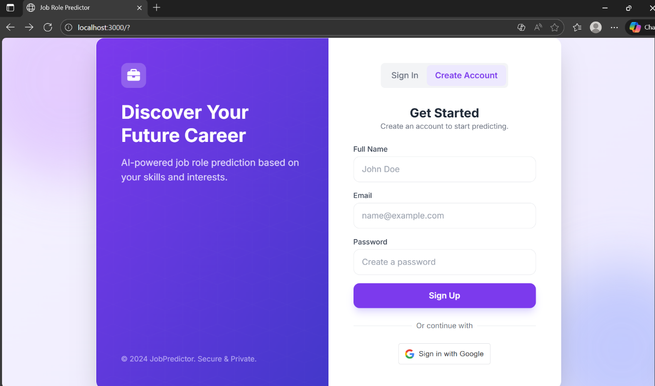

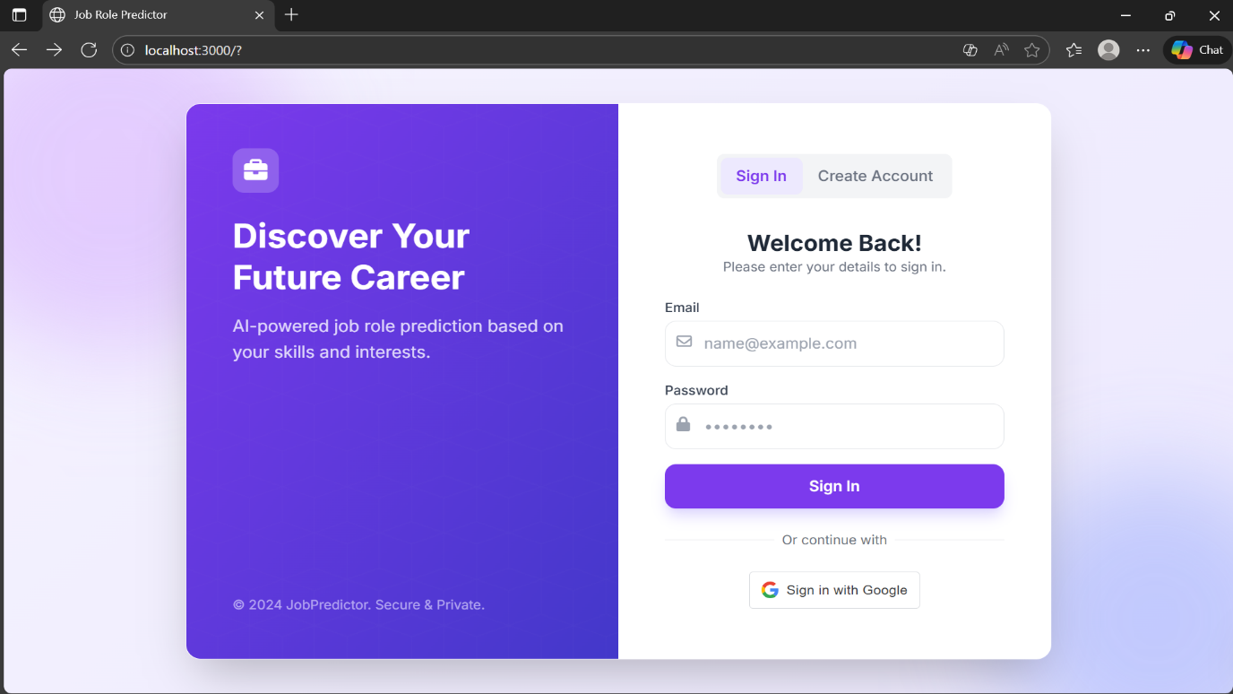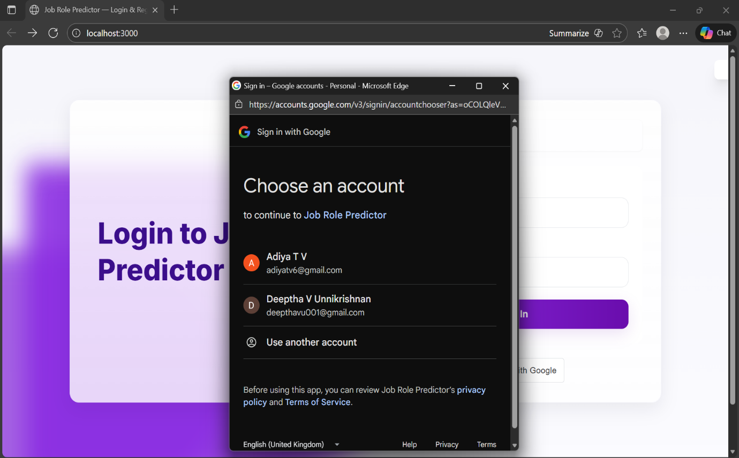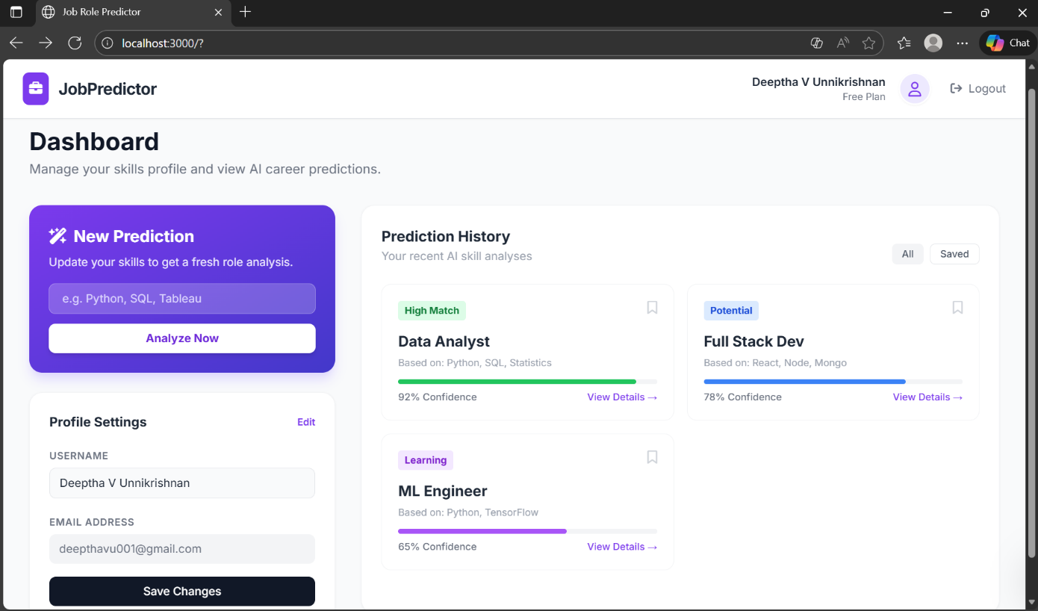
7.Conclusion :

In Milestone 1, the Edu2Job platform successfully established a secure and functional user management system. Users can now securely register and log in via standard email/password or Google OAuth. The implementation of JWT ensures secure API communication, and the responsive Dashboard provides the necessary interface for the upcoming modules.
This foundation is now ready for Milestone 2, which will involve integrating the Education Details Input forms and pre-processing that data for the Machine Learning model.

